SQL ASSIGNMENT 15

Q1. Assume there is a table called Multicust, with all of the same column definitions as Salespeople. Write a command that inserts all salespeople with more than one customer into this table.
Ans.
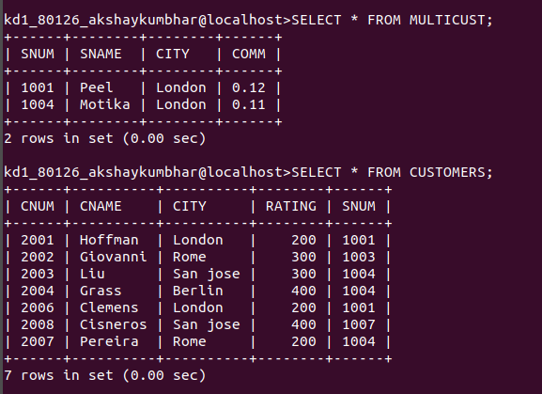

Q2. Write a command that deletes all customers with no current orders
Ans.
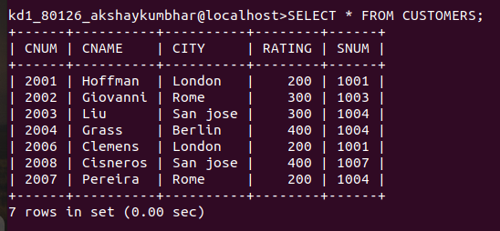

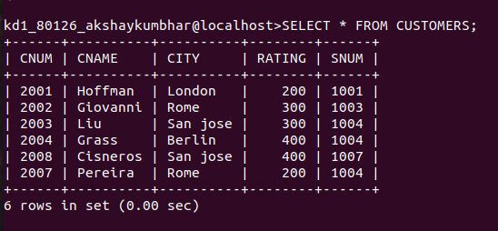

Q3. Write a command that increases by twenty percent the commissions of all salespeople with total orders above Rs. 3000.

Ans.

